**Population Ecology MYINT MYINT SOE Conservation ecology programme**

Eld’s Deer (*Rucervus eldii thamin*) population management

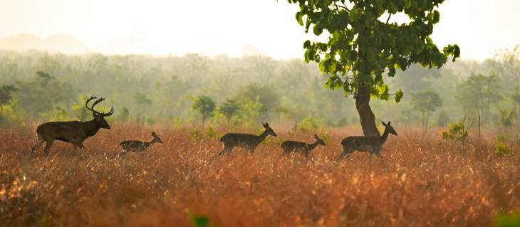

**Fig 1**. Eld’s Deer in Myanmar

* Endangered species Eld’s Deer (*Rucervus eldii thamin*) in Chatthin wildlife sanctuary, Myanmar
* They are facing population decline.

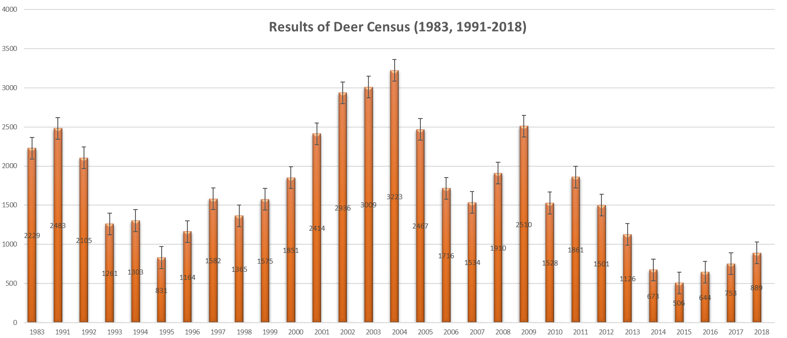

**Fig.2** Deer population trend in CWS

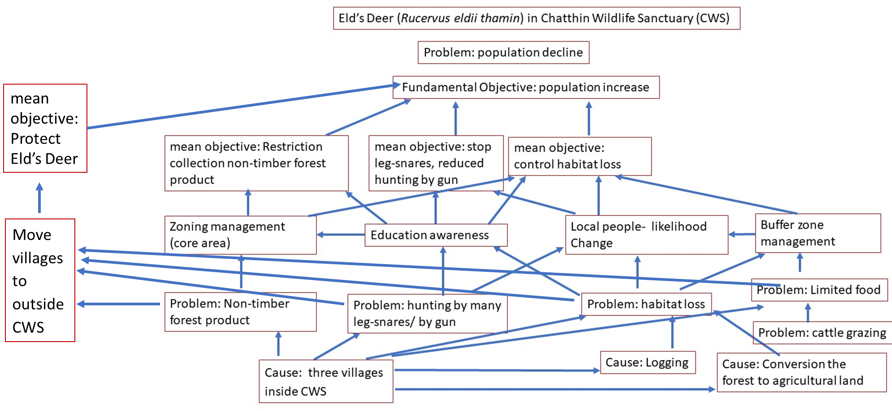

**Fig.3** Structure Decision Making Model for endangered species Eld’s Deer (*Rucervus eldii thamin*)

**Study site**

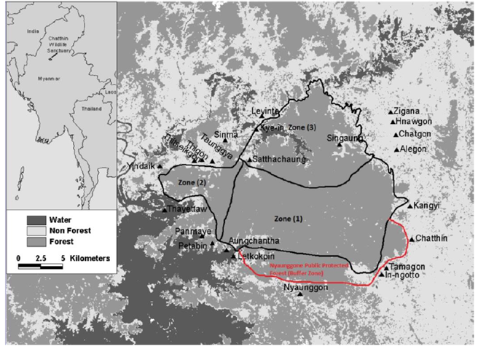

**Fig.4** Chatthin Wildlife Sanctuary (CWS)

Chatthin Wildlife Sanctuary, CWS covers some areas in Kanbalu and Kawlin townships, Sagaing Region, and it is situated in the central dry zone of Myanmar (95°24′E- 95°40′E, 23°30′N- 23°42′N). It was established in 1941, covering 104 sq.miles in which three villages are included. This protected area is especially significant for conserving an endangered species, Els’s Deer (*Rucervus eldii thamin*) and other wildlife species. However, the population of Els’s Deer is currently declining year by year.

**Problems**

Like other forest areas in Myanmar, CWS is threatened by encroachment of local communities for crop land, timber such as poles and posts. Socioeconomic and geographic surveys showed that local people rely on CWS especially for fuelwood and other non-timber forest products. Thus, local people spend considerable time within the sanctuary boundaries, resulting in disturbance to deer which make them have a very shy behavior. Moreover, hunting in the CWS or surrounding areas could be found. According to the rangers in CWS, hunting becomes a serious problem and villagers use many leg-snares and handmade guy. Grazing also has a negative impact on deer population of CWS, and in fact more than 50% of households with livestock use CWS area as the grazing site which can lead to many negative impacts on forest regeneration and biodiversity, and which can create competition of food between deer and cattle. Besides, population growth of the nearby villages poses a great pressure on the number of deer in CWS.

**Alternative actions to fix the prescribed problems**

Firstly, zoning management will be implemented in CWS, including Zone (1): Core zone which is to be kept free from human pressures, to conserve the flora and fauna species, and to create a more enabling environment for Els’s Deer and other wildlife species; Zone (2): Development zone which tends to restore the forest especially natural regeneration, and Zone (3) which is intended as a rehabilitation zone for local villagers from three villages inside the CWS, where they are granted for cattle grazing, fishing, and harvesting non-timber forest products.

Secondly, promoting awareness among the local people should be considered, aiming for reducing the pressure of human activities on wildlife species, and for stronger law enforcement. In order to accomplish second management practice, it should also be conducted an intensive education program for local people and the related authorities. Implementation of buffer zone management practice can lead to increasing deer population in CWS as well. Implementing some programs such as providing financial and technological support for cash crops and livestock possibly change the livelihood of the local people. Lastly, three villages inside CWS should be relocated to elsewhere outside CWS in order to reduce the tension on the population of the deer in CWS from human encroachment.

**Consequences**

Zoning management is a good practice model for the deer conservation because inside CWS, the local people are very poor with lower education level, and they have no choice other job for their survival, resulting in completely reliance on CWS for their livelihood. Therefore, sharing the use of natural resources among local people and wildlife species can become a “win-win” program. Awareness education not only creates close relation and mutual trust between the conservator and local communities but also reduce deer hunting. Buffer zones management should be promoted to support the villagers and local people with non-timber forest products, providing area for their cattle grazing and reducing human disturbance on CWS. Changing the livelihood of the local people can uplift the life of the residents and reduce their hunting practice that can pose a threat on deer population. Therefore, this practice will generate positive effect both on wildlife and the life of local people.

Relocating the villages inside CWS to other areas outside the wildlife sanctuary is definitely a good practice for wildlife conservation, but there are some constraints to accomplish this practice in Myanmar, including law enforcement, political issues, financial supporting problem and unwillingness of the local people to shift to other places. On the other hand, even if the relocation has been implemented by force, they might invade the area of CWS again, leading the illegal hunting and other activities.

Though specific options described can reduce the pressures on the population of deer in CWS, the ideal option that can optimize the maximum benefits is the combination of these four alternatives (zoning management, education awareness, buffer zone management and likelihood change on local people). This ideal scenario can be successfully implemented applying “Structure Decision Making” approach as illustrated in Fig.3.

**Trade off**

In order to conduct the above-mentioned alternatives, the financial and technical supports from the government and other related organizations including NGOs and INGOs are required. Besides, it needs to improve the willingness of the local people to conserve the nature, especially to restore the declining population of the Eld’s deer in CWS. With the active cooperation of these organizations, alternatives to increase the deer population in CWS would be successfully implemented.